England Hockey ClubsFirst

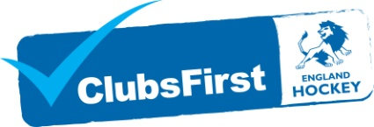

All clubs are encouraged to register and work towards gaining ClubsFirst, England Hockey's Club Accreditation Scheme. ClubsFirst is part of the Sport England Clubmark Programme and is nationally recognised as a standard mark for clubs. You can download the registration form for this scheme from the downloads section.

Why?
Clubs achieving the CLUBS 1ST award are recognised as working towards providing a Safe, Effective and Child Friendly hockey Environment. They also receive the CLUBMARK award. County Sports Partnerships and Funding agencies are increasingly recognising these clubs and choosing to work with them as a priority.

How?
To register for ClubsFirst just download a registration form, complete it and send it to England Hockey. There is a small charge of £20 to cover the resource and administration cost only.

